GEO-ANOM: A GEOAI for AFO Mapping and Spatially-Explicit Nutrient Transfer Optimization

PIs: Dr. Catherine Nakalembe, Asst. Professor, Dept. of Geographical Sciences, BSOS; AIM member; Stephanie Lansing, Professor, Dept. of Env. Science & Technology, AGNR; pending AIM member.
Collaborators: Dr. Eid Gul and Rafian Aziz (ENST/AGNR). Pradeep Kumar Yellapu and Jenny Ha (BSOS GEOG). Alisha Mulkey, Resource Conservation, Maryland Dept. of Agriculture;

ABSTRACT: We proposed developing GEO-ANOM, a Geospatial Artificial Intelligence (GEOAI) framework to optimize farm-waste technologies in Maryland’s agricultural landscape. The core challenge addressed is the reliance on generalized, low-resolution data for nutrient management, which constrains the optimal placement of waste-to-resource infrastructure. GEO-ANOM is designed to provide high-resolution, near real-time spatial data on both manure supply from Animal Feeding Operations (AFOs) and crop-specific nutrient demand. The framework integrates GEOAI, geospatial optimization, and sustainable agriculture technologies implemented through three tasks: 1) Nutrient Supply Mapping (NSM), using deep learning and multi-source satellite data to detect and map AFOs, 2) Nutrient Demand Mapping (NDM), utilizing the USDA’s Cropland Data Layer to create a spatially-explicit Nutrient Balance Map (NBM), and 3) Geospatial Optimization Modeling (GOM) to synthesize all data to determine the most sustainable and cost-effective sites for waste-to-resource facilities, including those using anaerobic digestion and gasification/biochar technologies. In alignment with AIM’s Sustainability goals, this project fosters a circular bioeconomy by facilitating the transfer of surplus nutrients from AFOs to crop areas in need. Expected outcomes include the first high-resolution, automated assessment of waste density and a data-driven baseline for nutrient loading hotspots. This actionable intelligence will guide public and private investment, reduce reliance on expensive synthetic fertilizers, support equitable resource distribution, and advance critical water-quality goals, thereby contributing to food security and agricultural policy.

PROPOSAL NARRATIVE - PURPOSE AND SIGNIFICANCE

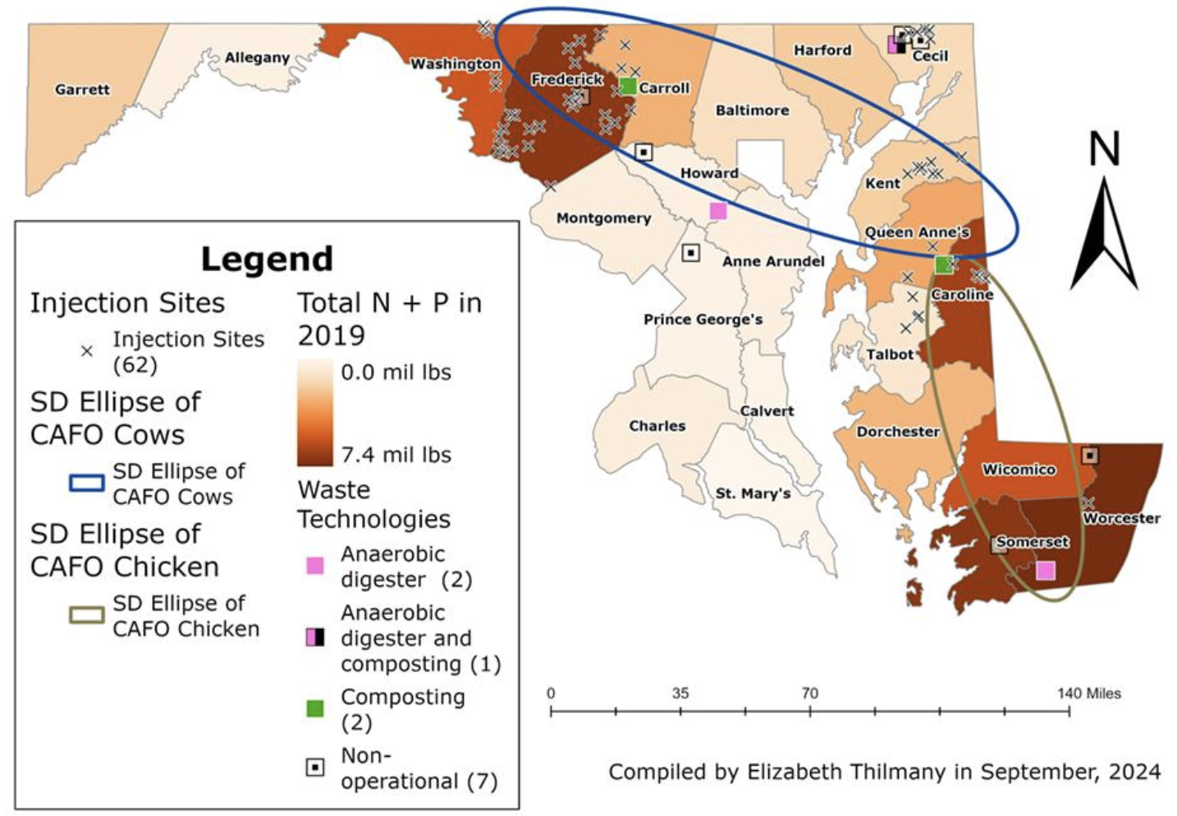
Problem Description: Effective nutrient management and optimal siting of waste-to-resource technologies in Maryland’s agricultural landscape are currently affected by significant data gaps in site location, type, and capacity. Current nutrient management and waste technology sites rely on generalized county-level data (Figure 1), outdated farm registries, and costly ground-truthing surveys. This approach fails to provide the high-resolution, near-real-time spatial data required for precise location decision-making. Notably, the lack of spatial data on manure supply from Animal Feeding Operations (AFOs) and crop nutrient demand is the primary barrier to optimizing the placement of new waste-to-resource infrastructure. Moreover, there is a lack of cohesive integration of recent Geospatial Artificial Intelligence (GEOAI) datasets and methods in Nutrient Supply Mapping, which limits the optimization of essential nutrient transfers, ultimately undermining the mitigation of associated environmental risks. To address these gaps, we proposed to develop GEO-ANOM: A GEOAI for AFO Mapping and Spatially-Explicit Nutrient Transfer Optimization.

Figure 1: Nutrient density (nitrogen + phosphorus) from animal manure in Maryland, with specificity only on a county basis, based on the current approach. The standard deviation (SD) ellipse captures county-level concentration (66.2%) of confined animal feeding operations (CAFOs) [1].

By developing GEO-AI methods to more efficiently and explicitly merge multi-model and fuse multi-source datasets, GEO-ANOM is highly relevant to AIM’s priority topic of Sustainability, which focuses on exploring climate, food security, agriculture, and aquaculture, aiming to improve public health, policy, and business. By addressing the lack of high-resolution spatial data critical for optimization, and by utilizing cutting-edge foundational geospatial datasets and AI, such as AlphaEarth and the Segment Anything Model (SAM), GEO-ANOM will produce a spatially-explicit Nutrient Balance Map (NBM). This NBM is a critical resource required by stakeholders, including the Maryland Departments of Environment (MDE) and Agriculture (MDA), private investors, and local farm communities, to guide resource management and waste-to-resource investments. This project is fundamentally connected to AIM’s focus areas of Sustainability and Accessibility by fostering a circular bioeconomy. The core objective is to map and facilitate the transfer of essential nutrients from surplus areas around AFOs to crop areas that need them [2]. By achieving this, the project will reduce local farms’ reliance on expensive synthetic fertilizers, support equitable resource distribution, generate renewable energy, advance critical water-quality goals with public health implications, and map resources critical to the Maryland Animal Waste Technology Assessment and Strategy [3].
Objectives and Rationale: The rationale for this project is grounded in the critical need to bridge the gap between existing geospatial data and precise decision-making in nutrient management. While existing data sources are available, the lack of cohesive integration with recent GEO-AI methods currently prevents their use for high-resolution, spatially-explicit optimization and cost-effective monitoring. We address this critical gap by pursuing three clear, measurable research objectives: (1) Develop a machine learning model to accurately detect and map AFO features, specifically animal waste lagoons and poultry houses, 2) quantify the efficiency gains of a GEOAI-driven approach in producing a spatially-explicit NBM, and 3). develop a framework to determine the most sustainable and cost-effective locations for new waste-to-resource technologies across Maryland.

METHODS AND APPROACH
Our GEO-ANOM intellectual framework is a multi-stage Spatial Analysis and Optimization workflow that integrates advanced geospatial machine learning with traditional spatial modeling grounded in three disciplines: 1). GEOAI combines multi-source remotely sensed Earth observation data, with machine learning (ML) and computer vision (CV) approaches; 2). Geospatial analysis and optimization; and 3). Sustainable agriculture using anaerobic digestion and gasification/biochar technologies [4]. The proposed project will be structured into three (3) main tasks:
Task 1: Nutrient Supply Mapping
In this task, we will establish a georeferenced training dataset AFOs in the state of Maryland. This will be accomplished through satellite image interpretation via Collect Earth Online and Google Earth Pro, in addition to existing field data. This dataset is crucial for training our ML and DL models, which will utilize multi-source satellite data to create a GEOAI-driven estimation framework for AFO waste supply. Foundational datasets, such as AlphaEarth [5], and AI techniques, including the Segment Anything Model (SAM) [6], will be fused with multi-source satellite data to achieve the necessary spatial resolution and temporal coverage for object detection and AFOs monitoring. SAM is particularly valuable for this task due to its ability to perform robust, high-quality, and generalizable zero-shot image segmentation, which is critical for accurately labeling the complex, heterogeneous shapes of AFO features, such as lagoons and poultry houses, for both training and eventual detection. We will develop guidelines and train undergraduates to label the complex, heterogeneous shapes of AFO features, such as lagoons and poultry houses, in the satellite imagery for the foundational training dataset.
Task 2: Nutrient Demand Mapping
USDA’s Cropland Data Layer [7], which includes crop type maps for the entire United States, will be utilized. Spatially explicit crop types and changes in cropping, also included in this data layer, are instrumental in assessing and estimating crop-specific nutrient requirements to create a spatially explicit NBM. Based on crop density and type, this data will be used to map and estimate nutrient demand across the landscape.
Task 3: Geospatial Optimization Modeling
Integrating all prior data (AFO supply from Task 1, NBM-derived demand from Task 2), along with geospatial layers on transportation costs, and relevant economic factors, is the final, critical step to create our GEO-ANOM. A comprehensive life cycle assessment will be conducted and added as a layer in the model to evaluate the environmental impact of several waste-to-resource pathways scenarios, including energy recovery potential, nutrient balance, and greenhouse gas emissions, in order to determine the environmental trade-off between the alternatives. The analysis will be performed using SimaPro, applying the ReCiPe 2016 (Hierarchist perspective) methodology to estimate midpoint environmental impacts based on detailed inventory input and output data. The assessment will cover multiple impact categories, including Climate change (kg CO₂-eq), Terrestrial acidification (kg SO₂-eq), Freshwater eutrophication (FE, kg P-eq), Photochemical oxidant formation (NMVOC), Fossil Depletion (kg oil-eq), Freshwater ecotoxicity (1,4-DCB-eq), Marine eutrophication (kg N-eq), Human toxicity-carcinogenic and non-carcinogenic (1,4-DCB-eq), Particulate matter formation (kg PM2.5-eq), Mineral resource scarcity/metal depletion (kg Cu-eq), Water consumption (m³), Terrestrial ecotoxicity (1,4-DCB-eq) and Marine ecotoxicity (1,4-DCB-eq).
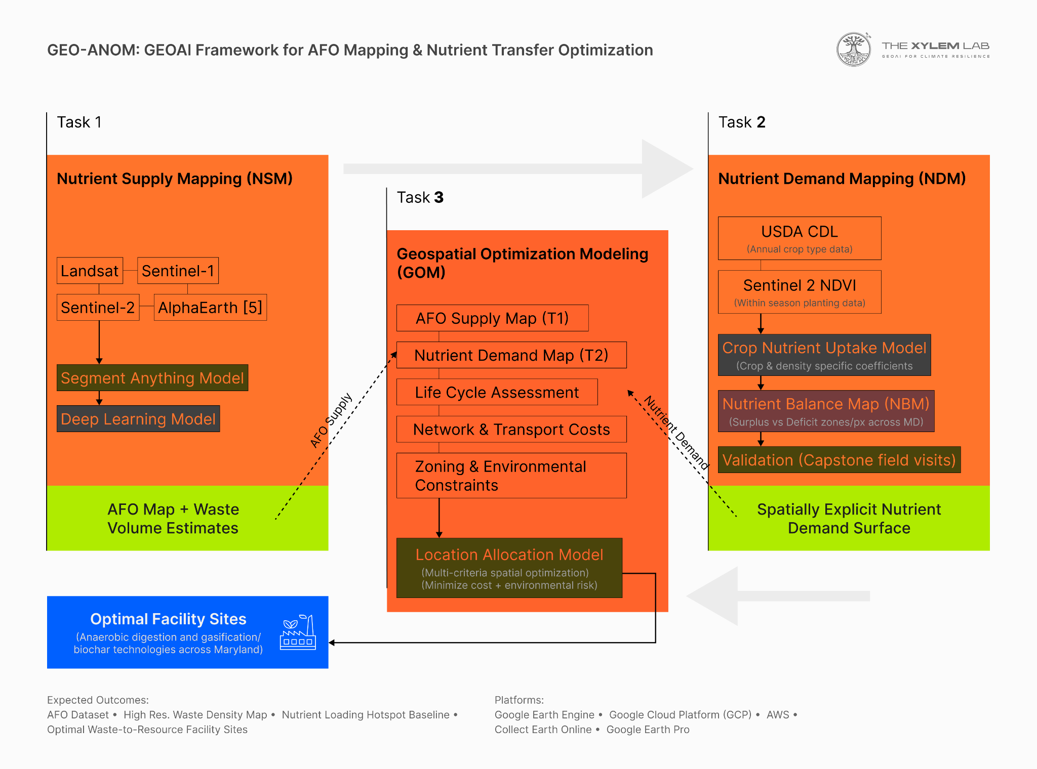
Figure 2: GEO-ANOM multi-stage GEOAI framework integrating Nutrient Supply Mapping (Task 1), Nutrient Demand Mapping (Task 2), and Geospatial Optimization Modeling (Task 3) to produce optimal waste-to-resource facility siting recommendations
This GEO-ANOM constitutes a rigorous, multi-stage Spatial Analysis and Optimization workflow that integrates advanced geospatial machine learning with traditional spatial modeling techniques. The model operates as a Location-Allocation Model that specifically leverages high-resolution, spatially explicit data to balance multiple criteria. By doing so, the model will determine the optimal sites for new waste-to-resource facilities. This process is designed to maximize cost-effective nutrient transfer from surplus AFO areas to areas of crop demand, while simultaneously minimizing the associated environmental risks and advancing critical water quality goals.
Datasets and Platforms
Data collection will include fusing multiple sources and leveraging existing foundational geospatial datasets, including Landsat, Sentinel 1 and 2, the AlphaEarth foundational dataset from Google [ref], and the USDA’s Cropland Data Layer {Updating}[ref]. Analysis will be conducted using deep learning and machine learning models for detection and monitoring, and geospatial optimization to produce the final site recommendations. Google Cloud Platform (GCP) for storage and Google Earth Engine for analysis. Collect Earth online and Google Earth Pro will be used for labelling, computing, and storage with supplementary use of Amazon Web Services being explored, for which credits are available as cost-share.
IMPACT AND EXPECTED OUTCOMES
Contributions to AI and Fields Impacted:
By successfully converging and integrating cutting-edge AI methods, specifically foundational models like AlphaEarth [5] and the SAM [6], with multi-source satellite data, GEO-ANOM will significantly advance the current capabilities of object detection and monitoring for complex environmental systems. This data-driven approach is critical for researchers spanning from AGNR, ENST, Computer Science and GEOG fields. Moreover, by replacing outdated, generalized county-level data with a high-resolution baseline for waste density and nutrient loading, our research will facilitate a more effective environmental planning and policy. Crucially, GEO-ANOM’s design prioritizes deployability by state agencies (e.g., MDE and MDA), ensuring the project's impact extends directly into real-world resource management beyond academic outputs.
Relation AIM’s Focus Area and Societal Impact:
In alignment with AIM’s priority of Sustainability, our project’s primary societal impact is the advancement of critical water-quality goals in Maryland. This is achieved by providing the first high-resolution, data-driven baseline for nutrient loading hotspots and minimizing associated environmental risks. By guiding the transfer of essential nutrients from surplus areas around AFOs to crop areas in need, the project delivers accessible organic nutrients to local farms, thereby promoting a more equitable and circular bioeconomy and reducing agriculture’s reliance on expensive synthetic fertilizers.
Expected Outcomes:
- Benchmark Labeled Dataset for AFOs.
- First High-Resolution, Semi-automated Assessment of waste density in the region.
- Data-Driven Baseline for nutrient loading hotspots.
- Identification of Optimal Facility Sites for waste-to-resource technologies.
- Key Publications targeting methodological GEOAI and the applied AGNR/ENST communities, and the establishment of an open dataset repository (Zenodo) for data, a GitHub repository for code, and a project website.

Interdisciplinary collaboration, Team Composition and Roles
Our project is structured around an effective cross-campus collaboration, intentionally bridging complementary expertise across the University of Maryland’s Geographical Sciences (BSOS GEOG), Environmental Science and Technology (ENST) in Agriculture and Natural Resources (AGNR) departments. This collaboration is strengthened by direct, active engagement with key Maryland state agencies.
Dr. Catherine Nakalembe (BSOS-GEOG): PI, leading the methodological GEOAI and remote sensing components essential for all proposed tasks (Nutrient Supply Mapping), and Dr. Stephanie Lansing (AGNR-ENST): Co-PI, leading the sustainable agriculture, waste technology, and nutrient management applications within Tasks 2 and 3. Our academic collaborators providing technical support in the machine learning component include Dr. Eid Gul and Rafian Aziz (AGNR-ENST), Pradeep Yellapu, and Jenny Ha. Stakeholder guidance, data access, and deployment pathways will be provided by Alisha Mulkey (MD Dept. of Agriculture), ensuring the model is relevant and applicable to Maryland’s state-level conservation and resilient strategies.

Communication Plan:
To ensure a seamless connection between the GEO-AI development and the applied environmental modeling, the GEOG and AGNR/ENST teams will maintain close coordination through regular bi-weekly research meetings, establishing a consistent progress report approach. Furthermore, the team is committed to continuous knowledge transfer and feedback. This will be accomplished through community outreach, which will include presentations and meetings with stakeholders such as MD state agencies, the MD Farm Bureau, Delmarva Poultry Association, and the Governmental Agricultural Commission. These engagements will ensure that the intelligence developed is contextually relevant, actionable to the greatest extent possible and responsive to the immediate needs of the stakeholders.
TIMELINES, MILESTONES, AND FUTURE WORK
Timeline (2026-2027) | Task | Milestone/Deliverables
July - September | Task 1: Nutrient Supply Mapping: Data acquisition (including all available multi-source geospatial datasets), initial GEOAI framework setup, training of deep models for AFOs detection. | Initial AFO georeferenced dataset established
October - December | Task 1(Continues): AFO supply estimation framework improved using foundational datasets (AlphaEarth and SAM) | High-resolution, automated assessment of waste density completed
January - March | Task 2: Nutrient Demand Mapping: utilize the USDA’s Cropland Data Layer to create a spatially-explicit NBM. | NBM completed
April - June | Task 3: Geospatial Optimization Modeling: integrate all data into the model | Final GEO-ANOM model release

Key Deliverables (June 2027):
- A developed and documented GEO-ANOM framework
- The first high-resolution waste density assessment and a data-driven baseline for nutrient loading hotspots
- A report identifying optimal facility sites for waste-to-resource technologies
Future Work:
- Key publications will be submitted, targeting both the methodological (CVPR or ACM SIGSPATIAL) GEOAI and the applied (ASABE) AGNR/ENST communities.
- The replicable GEOAI framework will be transitioned to state agencies for deployment and ongoing resource management.
- The team will pursue external funding proposals, leveraging the GEO-ANOM framework and its high-resolution data as a core innovation for broader, long-term environmental and agriculture initiatives.

Key References:
[1] Masson, L., Thilmany, E., Lansing, S., Wietelman, D., 2025. Maryland’s Nutrient, Animal Waste, and Technology Landscape (FS- 2024-0737). University of Maryland Extension. go.umd.edu/FS-2024-0737
[2] Lansing, S., 2025. Maryland Animal Waste Technology. https://extension.umd.edu/resource/animal-waste-technologies/.
[3] Lansing, S., Dill, S., Everts, K. Hassanein, A., Hendricks, M., et al., 2023. Maryland Animal Waste Technology Assessment and Strategy Planning. Final Report to Maryland Dept of Agriculture. https://extension.umd.edu/resource/maryland-animal-waste-technology-assessment-and-strategy-planning-report/. 116 pages.
[4] Mahoney, K., Hassanein, A., McCoy, E., Lansing, S. 2025. Novel farm-scale bioenergy and waste management: A life cycle assessment of anaerobic co-digestion and manure composting. Energy 334, 137737. https://doi.org/10.1016/j.energy.2025.137737.
[5] Brown, Christopher F., Michal R. Kazmierski, Valerie J. Pasquarella, William J. Rucklidge, Masha Samsikova, Chenhui Zhang et al., 2025. Alphaearth foundations: An embedding field model for accurate and efficient global mapping from sparse label data. arXiv preprint arXiv:2507.22291.
[6] Kirillov, Alexander, Eric Mintun, Nikhila Ravi, Hanzi Mao, Chloe Rolland, Laura Gustafson, Tete Xiao et al., 2023. Segment anything. In Proceedings of the IEEE/CVF International Conference on Computer Vision, pp. 4015-4026.
[7] USDA National Agricultural Statistics Service Cropland Data Layer, [YEAR], Published crop-specific data layer: USDA-NASS, accessed 2026-02-24 at https://nassgeodata.gmu.edu/CropScape/

BUDGET

Category | Budget Itemization (July 1, 2026 - June 30, 2027) | Amount
Personnel | Salaries and Benefits for Co-PIs (~2% effort), 2 Graduate Assistants (20 hrs/wk), and 1 Undergraduate Assistant (10 hrs/wk). Detailed stipends, benefits, and levels will be provided in the full Budget Justification. | $51,545
Community Engagement | Outreach, travel, and material costs for presentations and meetings with key stakeholders, including MD state agencies, the MD Farm Bureau, and the Governmental Agricultural Commission. | $500
Capstone Travel | Field site visits for Capstone groups to conduct ground-truthing of farm data. | $1,000
Conference Travel | Travel and registration for team members to conferences, including CVPR or ACM SIGSPATIAL, and ASABE ($3,000 per attendee). | $6,000
Google Cloud Platform (GCP) | Labeling, computing, and storage costs for data processing, student training, and researcher access. | $3000
AWS charges | Up to $10k of AWS credits available to S. Lansing as cost-share. | $0
 | Total | $62,045

BUDGET JUSTIFICATION

The total requested budget of $62,045 for the period of July 1, 2026, through June 30, 2027, is essential to successfully execute the three core tasks of the GEO-ANOM framework and achieve the proposed project deliverables. A detailed justification of the expenses follows. Personnel ($51,545)

Personnel costs are primarily dedicated to supporting the hands-on research and technical development.
Principal Investigators (Co-PIs): Salaries and benefits for Dr. Nakalembe (PI) and Dr. Lansing (Co-PI) are requested at a minimal effort level (approximately 2% each). This effort covers overall project management, bi-weekly coordination meetings, technical guidance for the research assistants, and final report/publication writing.
Graduate Assistants (2 GAs @ 20 hrs/wk): Two Graduate Assistants are critical to the project's success. One GA will focus on the methodological GEOAI development for Task 1 (Nutrient Supply Mapping), including deep learning model training and AFO feature detection. The second GA will support Task 2 (Nutrient Demand Mapping) and Task 3 (Geospatial Optimization Modeling), managing the NBM creation and running the Location-Allocation Model.
Undergraduate Assistant (1 UA @ 10 hrs/wk): One Undergraduate Assistant will provide crucial support for data labeling and annotation, specifically to establish the georeferenced AFO benchmark dataset required for training in Task 1.
Data and Computational Resources
- Google Cloud Platform (GCP) ($3,000): Funds are requested to cover labeling, computing, and storage costs. These resources are necessary for storing and processing the large volume of multi-source satellite data (Landsat, Sentinel 1 & 2) and for running the intensive deep learning models for AFO detection (Task 1) and the geospatial optimization models (Task 3). GCP will also be used for student training and researcher access to the final GEO-ANOM framework.
- AWS Charges ($0 - Cost-Share): The Co-PI, Dr. Lansing, has secured up to $10,000 in Amazon Web Services (AWS) credits as a formal cost-share. This resource will supplement the GCP resources, ensuring robust and redundant computational capacity for the project.
Dissemination and Outreach Travel
- Conference Travel ($6,000): Funds are requested to support travel and registration for key team members (e.g., PIs and/or GAs) to two major conferences (up to $3,000 per attendee). The selection targets both the methodological GEOAI community (e.g., CVPR or ACM SIGSPATIAL) and the applied environmental engineering/agriculture community (e.g., ASABE), ensuring the dissemination of "Key Publications" to both critical fields.
- Capstone Travel ($1,000): This fund supports field site visits for Capstone student groups to conduct ground-truthing of farm data. This is a vital expense for validating the accuracy of the GEOAI-derived AFO features and ensuring the reliability of the overall framework.
- Community Engagement ($500): This budget covers essential outreach, local travel, and material costs for meetings with stakeholders (MD state agencies, MD Farm Bureau, Governmental Agricultural Commission). This ensures the Communication Plan is executed effectively, guaranteeing the intelligence developed remains contextually relevant, actionable, and responsive to immediate stakeholder needs for deployment.

